**Cognizant_Digital Nurture 4.0_Deep Skilling**

**Programming Languages**

**Module 3 – PL/SQL Programming**

**Exercise 1: Control Structures**

**Scenario 1**

CREATE TABLE Customers (

    CustomerID NUMBER PRIMARY KEY,

    Name VARCHAR2(100),

    DOB DATE,

    Balance NUMBER,

    LastModified DATE

);

CREATE TABLE Loans (

    LoanID NUMBER PRIMARY KEY,

    CustomerID NUMBER,

    LoanAmount NUMBER,

    InterestRate NUMBER,

    StartDate DATE,

    EndDate DATE,

    FOREIGN KEY (CustomerID) REFERENCES Customers(CustomerID)

);

INSERT INTO Customers (CustomerID, Name, DOB, Balance, LastModified)

VALUES (1, 'John Doe', TO_DATE('1985-05-15', 'YYYY-MM-DD'), 1000, SYSDATE);

INSERT INTO Customers (CustomerID, Name, DOB, Balance, LastModified)

VALUES (2, 'Jane Smith', TO_DATE('1990-07-20', 'YYYY-MM-DD'), 1500, SYSDATE);

INSERT INTO Customers (CustomerID, Name, DOB, Balance, LastModified)

VALUES (3, 'Robert Grey', TO_DATE('1945-09-10', 'YYYY-MM-DD'), 25000, SYSDATE);

INSERT INTO Customers (CustomerID, Name, DOB, Balance, LastModified)

VALUES (4, 'Emily Clark', TO_DATE('1988-12-25', 'YYYY-MM-DD'), 9500, SYSDATE);

INSERT INTO Customers (CustomerID, Name, DOB, Balance, LastModified)

VALUES (5, 'Kevin Patel', TO_DATE('2000-03-03', 'YYYY-MM-DD'), 12000, SYSDATE);

INSERT INTO Loans (LoanID, CustomerID, LoanAmount, InterestRate, StartDate, EndDate)

VALUES (101, 1, 10000, 7, SYSDATE, ADD_MONTHS(SYSDATE, 12));

INSERT INTO Loans (LoanID, CustomerID, LoanAmount, InterestRate, StartDate, EndDate)

VALUES (102, 2, 8000, 6, SYSDATE, ADD_MONTHS(SYSDATE, 20));

INSERT INTO Loans (LoanID, CustomerID, LoanAmount, InterestRate, StartDate, EndDate)

VALUES (103, 3, 12000, 5.5, SYSDATE, ADD_MONTHS(SYSDATE, 10));

INSERT INTO Loans (LoanID, CustomerID, LoanAmount, InterestRate, StartDate, EndDate)

VALUES (104, 4, 9000, 6.5, SYSDATE, ADD_MONTHS(SYSDATE, 8));

INSERT INTO Loans (LoanID, CustomerID, LoanAmount, InterestRate, StartDate, EndDate)

VALUES (105, 5, 11000, 7.0, SYSDATE, ADD_MONTHS(SYSDATE, 15));

COMMIT;

BEGIN

    FOR cust IN (

        SELECT c.CustomerID, c.DOB, l.LoanID

        FROM Customers c

        JOIN Loans l ON c.CustomerID = l.CustomerID

    ) LOOP

        IF TRUNC(MONTHS_BETWEEN(SYSDATE, cust.DOB) / 12) > 60 THEN

            UPDATE Loans

            SET InterestRate = InterestRate - 1

            WHERE LoanID = cust.LoanID;

        END IF;

    END LOOP;

END;

/

SELECT * FROM Loans;

**Output:**

LoanID 103 (CustomerID 3 – Robert Grey, born 1945) had the interest rate successfully reduced from 5.5% to 4.5% because he is over 60 years old, confirming that the PL/SQL block worked perfectly.

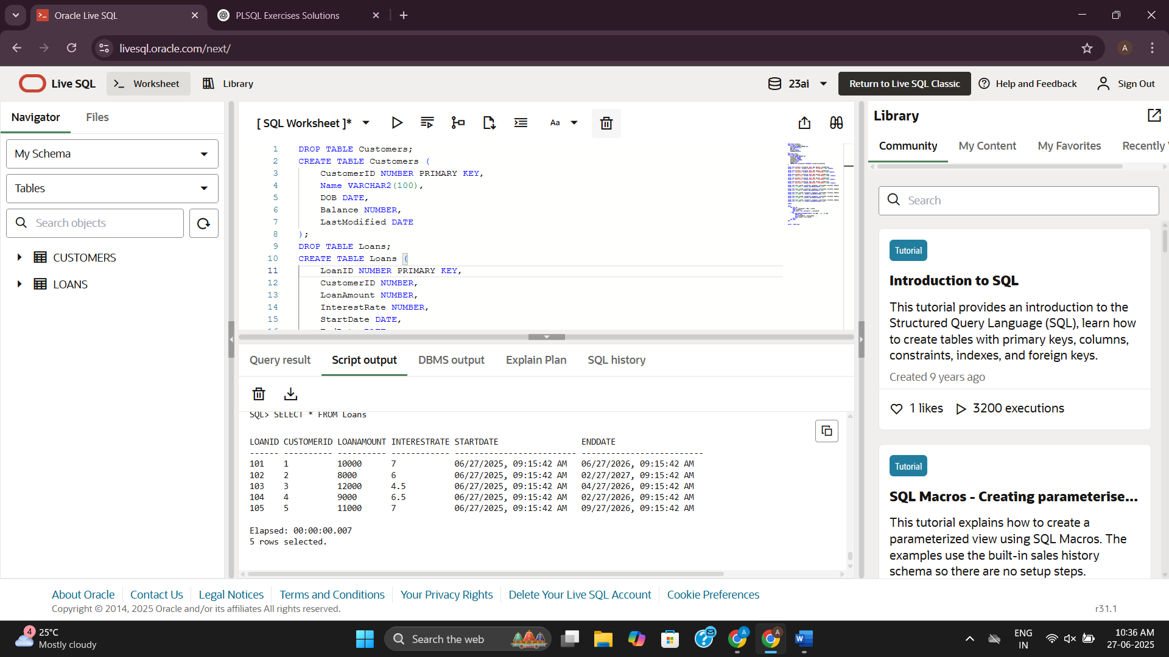

**Scenario 2**

CREATE TABLE Customers (

    CustomerID NUMBER PRIMARY KEY,

    Name VARCHAR2(100),

    DOB DATE,

    Balance NUMBER,

    LastModified DATE

);

INSERT INTO Customers (CustomerID, Name, DOB, Balance, LastModified)

VALUES (1, 'John Doe', TO_DATE('1985-05-15', 'YYYY-MM-DD'), 1000, SYSDATE);

INSERT INTO Customers (CustomerID, Name, DOB, Balance, LastModified)

VALUES (2, 'Jane Smith', TO_DATE('1990-07-20', 'YYYY-MM-DD'), 1500, SYSDATE);

INSERT INTO Customers (CustomerID, Name, DOB, Balance, LastModified)

VALUES (3, 'Robert Grey', TO_DATE('1945-09-10', 'YYYY-MM-DD'), 25000, SYSDATE);

INSERT INTO Customers (CustomerID, Name, DOB, Balance, LastModified)

VALUES (4, 'Emily Clark', TO_DATE('1988-12-25', 'YYYY-MM-DD'), 9500, SYSDATE);

INSERT INTO Customers (CustomerID, Name, DOB, Balance, LastModified)

VALUES (5, 'Kevin Patel', TO_DATE('2000-03-03', 'YYYY-MM-DD'), 12000, SYSDATE);

COMMIT;

ALTER TABLE Customers ADD IsVIP VARCHAR2(1);

BEGIN

    FOR cust IN (SELECT CustomerID, Balance FROM Customers) LOOP

        IF cust.Balance > 10000 THEN

            UPDATE Customers

            SET IsVIP = 'Y',

                LastModified = SYSDATE

            WHERE CustomerID = cust.CustomerID;

        ELSE

            UPDATE Customers

            SET IsVIP = 'N',

                LastModified = SYSDATE

            WHERE CustomerID = cust.CustomerID;

        END IF;

    END LOOP;

    COMMIT;

END;

/

SELECT CustomerID, Name, Balance, IsVIP FROM Customers;

**Output:**

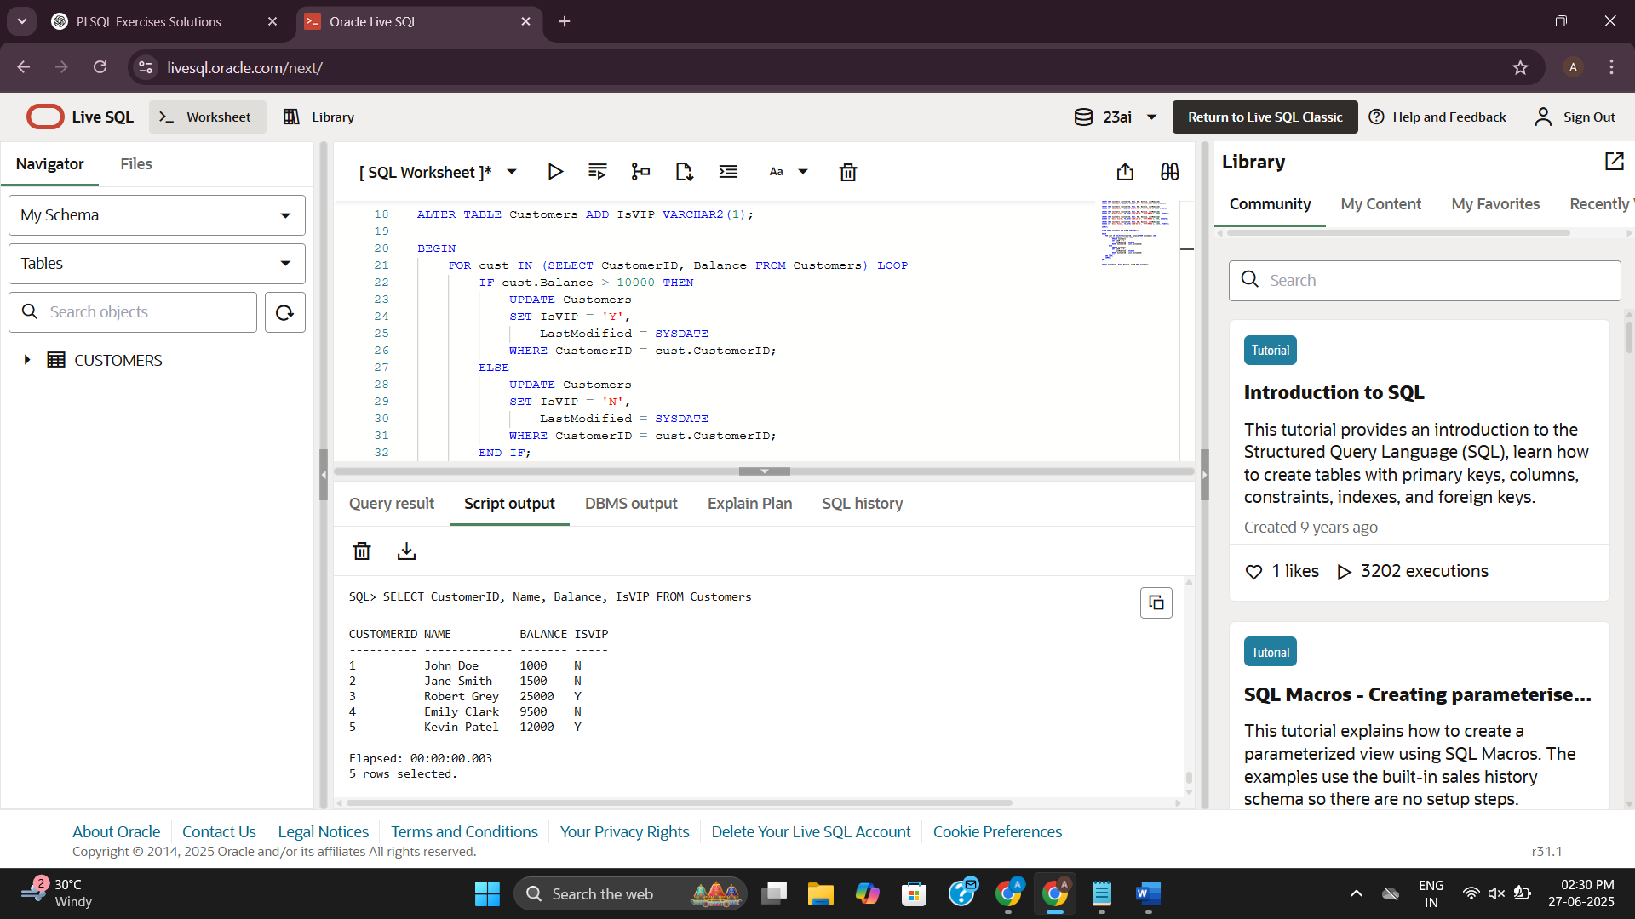

**Scenario 3**

CREATE TABLE Customers (

    CustomerID NUMBER PRIMARY KEY,

    Name VARCHAR2(100),

    DOB DATE,

    Balance NUMBER,

    LastModified DATE

);

CREATE TABLE Loans (

    LoanID NUMBER PRIMARY KEY,

    CustomerID NUMBER,

    LoanAmount NUMBER,

    InterestRate NUMBER,

    StartDate DATE,

    EndDate DATE,

    FOREIGN KEY (CustomerID) REFERENCES Customers(CustomerID)

);

INSERT INTO Customers (CustomerID, Name, DOB, Balance, LastModified)

VALUES (1, 'John Doe', TO_DATE('1985-05-15', 'YYYY-MM-DD'), 1000, SYSDATE);

INSERT INTO Customers (CustomerID, Name, DOB, Balance, LastModified)

VALUES (2, 'Jane Smith', TO_DATE('1990-07-20', 'YYYY-MM-DD'), 1500, SYSDATE);

INSERT INTO Customers (CustomerID, Name, DOB, Balance, LastModified)

VALUES (3, 'Robert Grey', TO_DATE('1945-09-10', 'YYYY-MM-DD'), 25000, SYSDATE);

INSERT INTO Customers (CustomerID, Name, DOB, Balance, LastModified)

VALUES (4, 'Emily Clark', TO_DATE('1988-12-25', 'YYYY-MM-DD'), 9500, SYSDATE);

INSERT INTO Customers (CustomerID, Name, DOB, Balance, LastModified)

VALUES (5, 'Kevin Patel', TO_DATE('2000-03-03', 'YYYY-MM-DD'), 12000, SYSDATE);

COMMIT;

INSERT INTO Loans (LoanID, CustomerID, LoanAmount, InterestRate, StartDate, EndDate)

VALUES (101, 1, 10000, 7, SYSDATE, ADD_MONTHS(SYSDATE, 12));

INSERT INTO Loans (LoanID, CustomerID, LoanAmount, InterestRate, StartDate, EndDate)

VALUES (102, 2, 8000, 6, SYSDATE, ADD_MONTHS(SYSDATE, 20));

INSERT INTO Loans (LoanID, CustomerID, LoanAmount, InterestRate, StartDate, EndDate)

VALUES (103, 3, 12000, 5.5, SYSDATE, ADD_MONTHS(SYSDATE, 10));

INSERT INTO Loans (LoanID, CustomerID, LoanAmount, InterestRate, StartDate, EndDate)

VALUES (104, 4, 9000, 6.5, SYSDATE, ADD_MONTHS(SYSDATE, 8));

INSERT INTO Loans (LoanID, CustomerID, LoanAmount, InterestRate, StartDate, EndDate)

VALUES (105, 5, 11000, 7.0, SYSDATE, ADD_MONTHS(SYSDATE, 15));

INSERT INTO Loans (LoanID, CustomerID, LoanAmount, InterestRate, StartDate, EndDate)

VALUES (106, 1, 5000, 5.5, SYSDATE, SYSDATE + 10);

COMMIT;

SET SERVEROUTPUT ON;

BEGIN

    FOR loan_rec IN (

        SELECT l.LoanID, l.LoanAmount, l.EndDate, c.Name

        FROM Loans l

        JOIN Customers c ON l.CustomerID = c.CustomerID

        WHERE l.EndDate BETWEEN SYSDATE AND SYSDATE + 30

    ) LOOP

        DBMS_OUTPUT.PUT_LINE(

            ' Reminder: Loan #' || loan_rec.LoanID ||

            ' for customer ' || loan_rec.Name ||

            ' is due on ' || TO_CHAR(loan_rec.EndDate, 'DD-MON-YYYY') ||

            '. Amount due: $' || loan_rec.LoanAmount

        );

    END LOOP;

END;

/

**Output:**

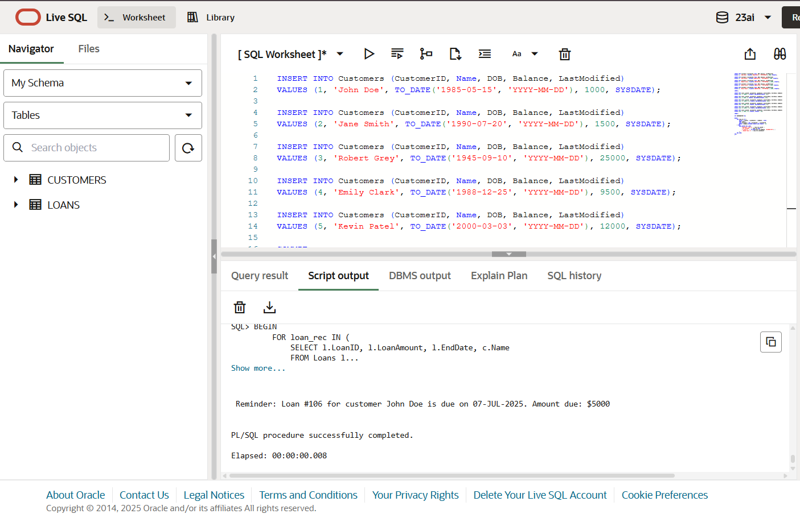

**Exercise 3: Stored Procedures**

**Scenario 1**

CREATE TABLE Accounts (

AccountID NUMBER PRIMARY KEY,

CustomerID NUMBER,

AccountType VARCHAR2(20),

Balance NUMBER,

LastModified DATE,

FOREIGN KEY (CustomerID) REFERENCES Customers(CustomerID)

);

CREATE TABLE Transactions (

TransactionID NUMBER PRIMARY KEY,

AccountID NUMBER,

TransactionDate DATE,

Amount NUMBER,

TransactionType VARCHAR2(10),

FOREIGN KEY (AccountID) REFERENCES Accounts(AccountID)

);

INSERT INTO Accounts (AccountID, CustomerID, AccountType, Balance, LastModified)

VALUES (1, 1, 'Savings', 1000, SYSDATE);

INSERT INTO Accounts (AccountID, CustomerID, AccountType, Balance, LastModified)

VALUES (2, 2, 'Checking', 1500, SYSDATE);

INSERT INTO Accounts (AccountID, CustomerID, AccountType, Balance, LastModified)

VALUES (3, 1, 'Savings', 2000, SYSDATE);

INSERT INTO Accounts (AccountID, CustomerID, AccountType, Balance, LastModified)

VALUES (4, 2, 'Savings', 1800, SYSDATE);

INSERT INTO Accounts (AccountID, CustomerID, AccountType, Balance, LastModified)

VALUES (5, 1, 'Checking', 1200, SYSDATE);

COMMIT;

INSERT INTO Transactions (TransactionID, AccountID, TransactionDate, Amount, TransactionType)

VALUES (1, 1, SYSDATE, 200, 'Deposit');

INSERT INTO Transactions (TransactionID, AccountID, TransactionDate, Amount, TransactionType)

VALUES (2, 2, SYSDATE, 300, 'Withdrawal');

INSERT INTO Transactions (TransactionID, AccountID, TransactionDate, Amount, TransactionType)

VALUES (3, 3, SYSDATE, 500, 'Deposit');

INSERT INTO Transactions (TransactionID, AccountID, TransactionDate, Amount, TransactionType)

VALUES (4, 4, SYSDATE, 300, 'Withdrawal');

INSERT INTO Transactions (TransactionID, AccountID, TransactionDate, Amount, TransactionType)

VALUES (5, 5, SYSDATE, 150, 'Deposit');

-- Optional: Create a sequence for generating unique TransactionIDs if not already present

CREATE SEQUENCE Transaction_Seq START WITH 1000 INCREMENT BY 1;

-- Create the procedure to process monthly interest

CREATE OR REPLACE PROCEDURE ProcessMonthlyInterest AS

    v_interest NUMBER;

BEGIN

    -- Loop through all savings accounts

    FOR acc IN (

        SELECT AccountID, Balance

        FROM Accounts

        WHERE AccountType = 'Savings'

    ) LOOP

        -- Calculate 1% interest

        v_interest := acc.Balance * 0.01;

        -- Update the balance in the Accounts table

        UPDATE Accounts

        SET Balance = Balance + v_interest,

            LastModified = SYSDATE

        WHERE AccountID = acc.AccountID;

        -- Insert a transaction record for the interest

        INSERT INTO Transactions (

            TransactionID,

            AccountID,

            TransactionDate,

            Amount,

            TransactionType

        ) VALUES (

            Transaction_Seq.NEXTVAL,

            acc.AccountID,

            SYSDATE,

            v_interest,

            'Interest'

        );

    END LOOP;

    COMMIT;

END;

/

EXEC ProcessMonthlyInterest;

SELECT AccountID, AccountType, Balance, LastModified

FROM Accounts

WHERE AccountType = 'Savings';

SELECT TransactionID, AccountID, TransactionDate, Amount, TransactionType

FROM Transactions

WHERE TransactionType = 'Interest'

ORDER BY TransactionID;

**Output:**

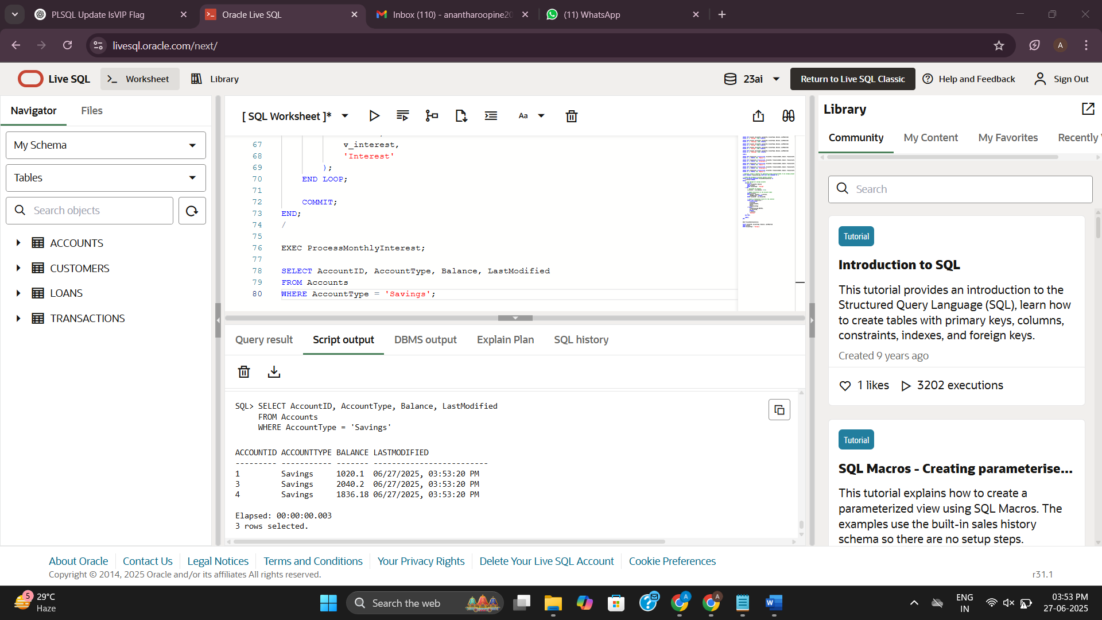

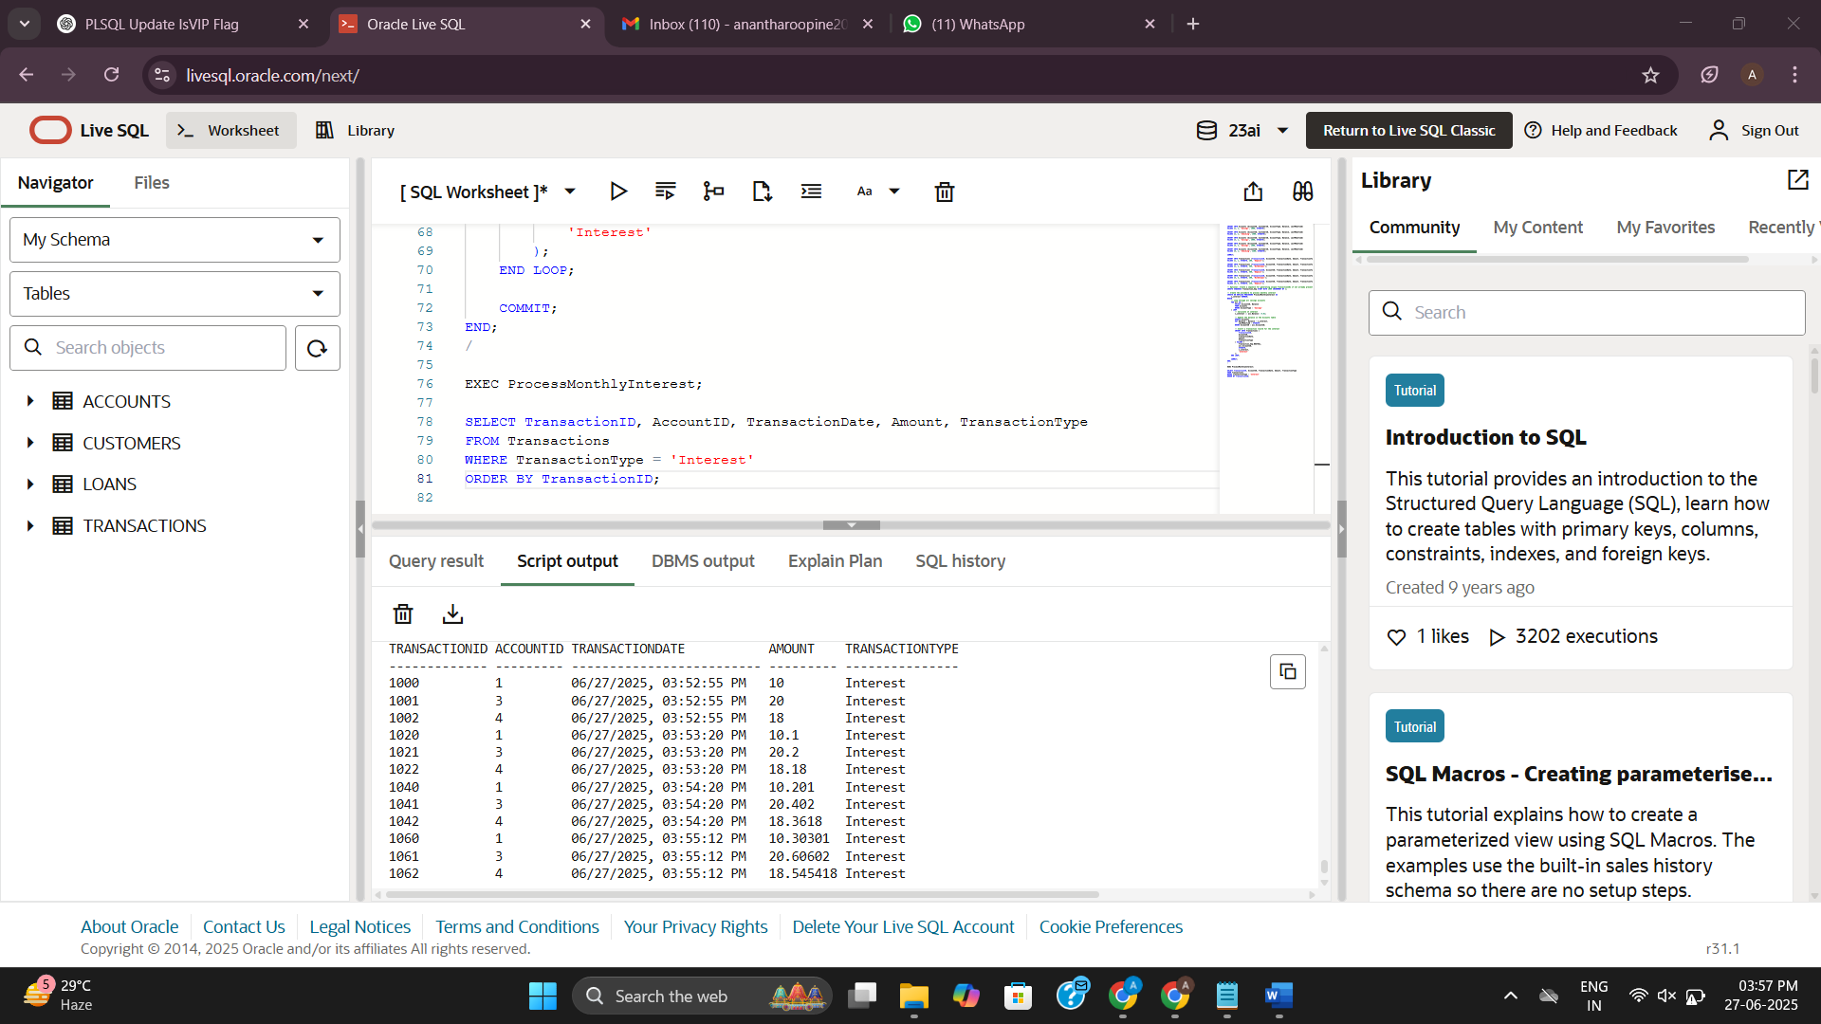

**Scenario 2**

CREATE TABLE Employees (

    EmployeeID NUMBER PRIMARY KEY,

    Name VARCHAR2(100),

    Position VARCHAR2(50),

    Salary NUMBER,

    Department VARCHAR2(50),

    HireDate DATE

);

INSERT INTO Employees (EmployeeID, Name, Position, Salary, Department, HireDate)

VALUES (1, 'Alice Johnson', 'Manager', 70000, 'HR', TO_DATE('2015-06-15', 'YYYY-MM-DD'));

INSERT INTO Employees (EmployeeID, Name, Position, Salary, Department, HireDate)

VALUES (2, 'Bob Brown', 'Developer', 60000, 'IT', TO_DATE('2017-03-20', 'YYYY-MM-DD'));

INSERT INTO Employees (EmployeeID, Name, Position, Salary, Department, HireDate)

VALUES (3, 'Carol Smith', 'Analyst', 55000, 'Finance', TO_DATE('2018-11-05', 'YYYY-MM-DD'));

INSERT INTO Employees (EmployeeID, Name, Position, Salary, Department, HireDate)

VALUES (4, 'David Lee', 'Support Engineer', 48000, 'IT', TO_DATE('2019-07-12', 'YYYY-MM-DD'));

INSERT INTO Employees (EmployeeID, Name, Position, Salary, Department, HireDate)

VALUES (5, 'Eva Martin', 'HR Assistant', 42000, 'HR', TO_DATE('2020-02-28', 'YYYY-MM-DD'));

COMMIT;

CREATE OR REPLACE PROCEDURE UpdateEmployeeBonus (

    p_department IN VARCHAR2,

    p_bonus_percent IN NUMBER

) AS

BEGIN

    -- Update salaries of employees in the specified department

    UPDATE Employees

    SET Salary = Salary + (Salary * p_bonus_percent / 100)

    WHERE Department = p_department;

    COMMIT;

END;

/

EXEC UpdateEmployeeBonus('IT', 10);

SELECT EmployeeID, Name, Department, Salary FROM Employees;

**Output:**

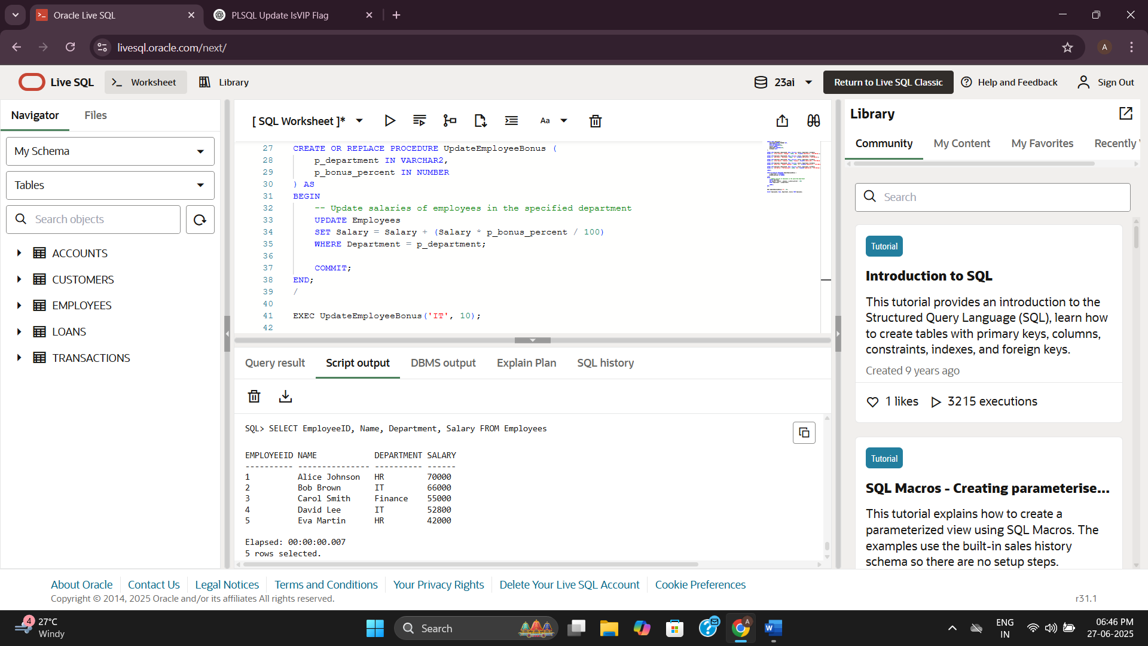

**Scenario 3**

CREATE TABLE Transactions (

TransactionID NUMBER PRIMARY KEY,

AccountID NUMBER,

TransactionDate DATE,

Amount NUMBER,

TransactionType VARCHAR2(10),

FOREIGN KEY (AccountID) REFERENCES Accounts(AccountID)

);

INSERT INTO Transactions (TransactionID, AccountID, TransactionDate, Amount, TransactionType)

VALUES (1, 1, SYSDATE, 200, 'Deposit');

INSERT INTO Transactions (TransactionID, AccountID, TransactionDate, Amount, TransactionType)

VALUES (2, 2, SYSDATE, 300, 'Withdrawal');

INSERT INTO Transactions (TransactionID, AccountID, TransactionDate, Amount, TransactionType)

VALUES (3, 3, SYSDATE, 500, 'Deposit');

INSERT INTO Transactions (TransactionID, AccountID, TransactionDate, Amount, TransactionType)

VALUES (4, 4, SYSDATE, 300, 'Withdrawal');

INSERT INTO Transactions (TransactionID, AccountID, TransactionDate, Amount, TransactionType)

VALUES (5, 5, SYSDATE, 150, 'Deposit');

ALTER TABLE Transactions

MODIFY TransactionType VARCHAR2(20);

CREATE OR REPLACE PROCEDURE TransferFunds (

    p_from_account_id IN NUMBER,

    p_to_account_id IN NUMBER,

    p_amount IN NUMBER

) AS

    v_from_balance NUMBER;

BEGIN

    -- Get current balance of source account

    SELECT Balance INTO v_from_balance

    FROM Accounts

    WHERE AccountID = p_from_account_id

    FOR UPDATE;

    -- Check if balance is sufficient

    IF v_from_balance < p_amount THEN

        RAISE_APPLICATION_ERROR(-20001, 'Insufficient balance in source account.');

    END IF;

    -- Deduct amount from source account

    UPDATE Accounts

    SET Balance = Balance - p_amount,

        LastModified = SYSDATE

    WHERE AccountID = p_from_account_id;

    -- Add amount to destination account

    UPDATE Accounts

    SET Balance = Balance + p_amount,

        LastModified = SYSDATE

    WHERE AccountID = p_to_account_id;

    -- Insert transaction for source account

    INSERT INTO Transactions (

        TransactionID, AccountID, TransactionDate, Amount, TransactionType

    ) VALUES (

        Transaction_Seq.NEXTVAL, p_from_account_id, SYSDATE, p_amount, 'Transfer Out'

    );

    -- Insert transaction for destination account

    INSERT INTO Transactions (

        TransactionID, AccountID, TransactionDate, Amount, TransactionType

    ) VALUES (

        Transaction_Seq.NEXTVAL, p_to_account_id, SYSDATE, p_amount, 'Transfer In'

    );

    COMMIT;

END;

/

EXEC TransferFunds(1, 2, 500);

SELECT * FROM Transactions ORDER BY TransactionDate DESC;

**Output:**

